
Kathmandu BernHardt College
Bafal, Kathmandu
Pre-Board Examination-2080
Set ‘A’
Institution: BSC.CSIT FM: 60
Subject: Physics (PHY113) PM: 30
Level: B.Sc. CSIT 1st Sem Time: 3hrs
_ ______________________________________________________________________________________________________________________________ __________________________________________________________________________________________________________________________________________________________________________________________________________________
Candidate are required to give their answers in their own words as far as practicable. The figure in the margin indicate full marks
Group ‘A’
Long Answer Question
Attempt any TWO questions [10 $×$ 2 = 20]
- What is Lorentz force? Derive an expression for the torque produced in a current carrying loop placed in uniform magnetic field and hence find the expression for potential energy of dipole. Discuss it.
- Define barrier potential in junction diode. Discuss equilibrium current condition and the relation for current in junction diode at given temperature.
- What do you mean by wavefunction? Discuss its physical significance. Set up time independent and time-dependent Schrödinger wave equation. What are implications of this equations? Discuss.
Group ‘B’
Short Answer Question
Attempt any EIGHT questions [5 $×$ 8 = 40]
- Explain how Franck-Hartz experiment demonstrates the existence of discrete energy level in atoms.
- What do you mean by Bloch theorem? Discuss its use in Krönig -Penny model and hence in band theory.
- Describe the following process of IC production: (a) Oxidation, (b) Pattern definition, and (c) Doping.
- A block is oscillating with an amplitude of 300 mm. The spring constant is 150 Nm^{–1}. (a) What is the energy of the system? (b) When the displacement is 5 cm, what is the kinetic energy of the block and the potential energy of the spring?
- What voltage must be applied to an electron to produce electrons of wavelength
0.50 $A°$?
- A particle in the ground state, that is, one represented by the wave function of Ψ = $\sqrt{\frac{2}{a}}sin⁡\left(\frac{nπ}{a}\right)x$. What is (a) the average position, (b) the average momentum, and (c) the average energy of such a particle?
- There are 2.5 X 10²⁸ free electrons per cubic meter of sodium. Calculate the Fermi energy and Fermi velocity.
- The reverse saturation current of a Silicon diode is $i_{0}$ =5 X 10-9$A°$. The voltage across the diode when forward biased is 0.4 V.
a. what is the current through the diode at T=27$℃$ ?

b. If the voltage across the diode is held constant, and we assume that $i_{0}$ doesn’t change with temperature, what is the current through the diode at T=47$℃$ ?
- Analyze the circuit in the figure below. Determine the logic function performed by the circuit by making and justifying the appropriate truth table.
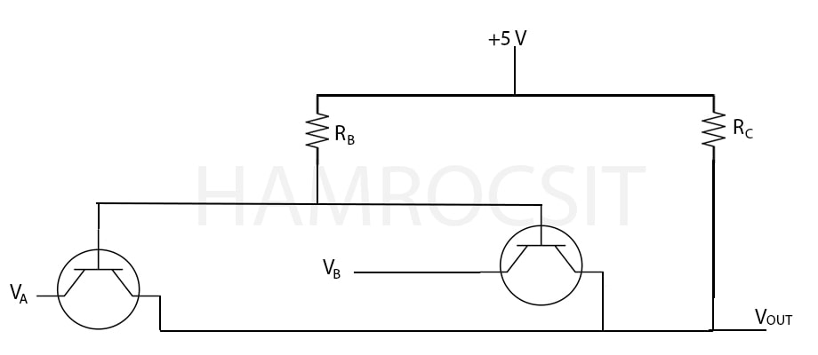

Best of Luck!


Kathmandu BernHardt College
Bafal, Kathmandu
Pre-Board Examination-2080
Set ‘B’
Institution: BSC.CSIT FM: 60
Subject: Physics (PHY113) PM: 30
Level: B.Sc. CSIT 1st Sem Time: 3hrs
_ ______________________ _________________________________________________________________________________________________________________________________________________________________________________________________________________________________________________________________________________________________________________________
Candidate are required to give their answers in their own words as far as practicable. The figure in the margin indicate full marks
Group ‘A’
Long Answer Question
Attempt any TWO questions [10 $×$ 2 = 20]
- Explain the theory of blackbody radiation. Why this theory needs Quantum mechanical interpretation? How this interpretation became experimentally successful? Explain
- What is extrinsic semiconductor? Derive the expression for carrier concentration of N-type semi-conductor and also show that Fermi energy level at moderate temperature lies near the middle of the donor atom energy level and bottom of conduction band.
- Set up Schrodinger equation for Hydrogen atom using spherical polar coordinates and separate radial and angular part of this equation. Without solving these equations discuss the various quantum numbers associated with these.
Group ‘B’
Short Answer Question
Attempt any EIGHT questions [5 $×$ 8 = 40]
- What is de Broglie’s hypothesis? How it is verified experimentally?
- Derive the time independent Schrodinger wave equation for the particle. Give the physical significance of wave function.
- Discuss how Astable multivibrator produces the periodic pulses with appropriate circuit diagram.
- A car driver travelling at 24 m/s applies the breaks, decelerates uniformly, and comes to a stop in 100 m. If the wheel has a radius of 0.30 m, what is the angular deceleration of the wheels in rev/s²?
- In a Hall experiment, a current of 25 A is passed through a long foil of silver which is 0.1 cm thick and 3cm long. Calculate the Hall voltage produces across the width of magnetic field perpendicular to plane of foil is 1.4 T, if the concentration of electron in silver is 6.8 × 10²⁸ electrons/m³. Also, estimate the mobility and Hall coefficient.
- What is the probability of finding a particle in$\frac{3}{4}$ th of width of well L from the wall if n=1, if n = 2 and if n = 3, use the normalized wave function $ϕ \left(x,t\right)$ =$√(\frac{2}{L})$ sin$\frac{nπx}{L}$ $e^{-\frac{iE2πt}{h}}$ .
- Consider a copper wire of cross-section area 1 mm² carrying a current 1A. What is the drift velocity of the electron? The density and molecular weight of Cu are 9 gm/cm³ and 64 gm/mole respectively.
- The energy gap in germanium is 0.67 eV. The electron and the hole effective masses are 0.12m and 0.23m respectively, where m is the mass of free electron. Calculate a. the Fermi energy, b. the electron density and c. the hole density at T = 300K.

- The output of a digital circuit (Y) is given by the expression:
$Y=(B+\overline{C}\overline{B}\overline{A})(\overline{A+C})$
where A, B and C represent inputs. Draw circuit of above equation using OR, AND and NOT gate along with truth table.

Best of Luck!

